 

A Minor Project Report

on

AUTOMATIC TRAFFIC SIGNAL

Submitted in partial fulfilment of requirements for the award of the degree

of

**BACHELOR OF ENGINEERING**

in

**COMPUTER SCIENCE AND ENGINEERING**

Under the guidance of

### Mrs. K. MAKANYADEVI M.E.,

### Assistant Professor/CSE

Submitted By



**BHUVANESHWARI. V (927622BCS015)**

**DHANUSRI. M (927622BCS022)**

**HARINI. S (927622BCS032)**

**ILAYA BHARATHI. S (927622BCS303)**

**DEPARTMENT OF COMPUTER SCIENCE AND ENGINEERING**

**M.KUMARASAMY COLLEGE OF ENGINEERING**

(Autonomous)

**KARUR – 639 113**

MAY 2024

 

# M. KUMARASAMY COLLEGE OF ENGINEERING

**(Autonomous Institution affiliated to Anna University, Chennai)**

# KARUR – 639 113

**BONAFIDE CERTIFICATE**

Certified that this minor project report on **“AUTOMATIC TRAFFIC SIGNAL”** is the bonafide work of **“BHUVANESHWARI. V (927622BCS015), DHANUSRI. M (927622BCS022), HARINI. S (927622BCS032), ILAYA BHARATHI. S (927622BCS303)”** who carried out the project work during the academic year 2023 - 2024 under my supervision.



|  |  |
| --- | --- |
| Signature | Signature |
| **Mrs. K. MAKANYADEVI M.E.,** | **Dr. M. MURUGESAN M.E., Ph.D.,** |
| **SUPERVISOR,** | **HEAD OF THE DEPARTMENT,** |
| Department of Computer Science | Department of Computer Science |
| and Engineering, | and Engineering, |
| M. Kumarasamy College of Engineering, | M. Kumarasamy College of Engineering, |
| Thalavapalayam, Karur -639 113. | Thalavapalayam, Karur -639 113. |

 

**DEPARTMENT OF COMPUTER SCIENCE AND ENGINEERING**

**VISION OF THE INSTITUTION**

To emerge as a leader among the top institutions in the field of technical education

**MISSION OF THE INSTITUTION**

* Produce smart technocrats with empirical knowledge who can surmount the global challenges
* Create a diverse, fully-engaged, learner-centric campus environment to provide quality education to the students
* Maintain mutually beneficial partnerships with our alumni, industry, and Professional associations

**VISION OF THE DEPARTMENT**

To achieve education and research excellence in Computer Science and Engineering

**MISSION OF THE DEPARTMENT**

* To excel in academic through effective teaching learning techniques
* To promote research in the area of computer science and engineering with the focus on innovation
* To transform students into technically competent professionals with societal and ethical responsibilities

**PROGRAM EDUCATIONAL OBJECTIVES (PEOs)**

**PEO 1:** Graduates will have successful career in software industries and R&D divisions through continuous learning.

**PEO 2:** Graduates will provide effective solutions for real world problems in the key domain of computer science and engineering and engage in lifelong learning.

**PEO 3:** Graduates will excel in their profession by being ethically and socially responsible.



**PROGRAM OUTCOMES (POs)**

Engineering students will be able to:

1. **Engineering knowledge:** Apply the knowledge of mathematics, science, engineering fundamentals, and an engineering specialization to the solution of complex engineering problems.
2. **Problem analysis:** Identify, formulate, review research literature, and analyze complex engineering problems reaching substantiated conclusions using first principles of mathematics, natural sciences, and engineering sciences.
3. **Design/development of solutions:** Design solutions for complex engineering problems and design system components or processes that meet the specified needs with appropriate consideration for the public health and safety, and the cultural, societal, and environmental considerations.
4. **Conduct investigations of complex problems:** Use research-based knowledge and research methods including design of experiments, analysis and interpretation of data, and synthesis of the information to provide valid conclusions.
5. **Modern tool usage:** Create, select, and apply appropriate techniques, resources, and modern engineering and IT tools including prediction and modeling to complex engineering activities with an understanding of the limitations.
6. **The engineer and society:** Apply reasoning informed by the contextual knowledge to assess societal, health, safety, legal and cultural issues and the consequent responsibilities relevant to the professional engineering practice.
7. **Environment and sustainability:** Understand the impact of the professional engineering solutions in societal and environmental contexts, and demonstrate the knowledge of, and need for sustainable development.
8. **Ethics:** Apply ethical principles and commit to professional ethics and responsibilities and norms of the engineering practice.
9. **Individual and team work:** Function effectively as an individual, and as a member or leader in diverse teams, and in multidisciplinary settings.
10. **Communication:** Communicate effectively on complex engineering activities with the engineering community and with society at large, such as, being able to comprehend and write effective reports and design documentation, make effective presentations, and give and receive clear instructions.

 

1. **Project management and finance:** Demonstrate knowledge and understanding of the engineering and management principles and apply these to one’s own work, as a member and leader in a team, to manage projects and in multidisciplinary environments.
2. **Life-long learning:** Recognize the need for, and have the preparation and ability to engage in independent and life-long learning in the broadest context of technological change.

**PROGRAM SPECIFIC OUTCOMES (PSOs)**

1. **PSO1: Professional Skills:** Ability to apply the knowledge of computing techniques to design and develop computerized solutions for the problems.
2. **PSO2: Successful career:** Ability to utilize the computing skills and ethical values in creating a successful career.

# ABSTRACT

# Traffic congestion in highly populated urban areas is a huge problem these days. A lot of researchers have proposed many systems to monitor traffic flow and handle congestion through different techniques. But the current systems are not reliable enough to perceive traffic signals in real-time. Therefore, it is aimed to build a system that can efficiently perform real-time environments to solve the traffic congestion problem through signal automation. Since vehicle detection and counting are crucial in any traffic system, Here use state-of-the-art deep learning techniques to detect and count vehicles in real-time. Then automate the signal timings by comparing the count of traffic on all sides of a junction. These automated signal timings sufficiently reduce congestion and improve traffic flow.

 

# ABSTRACT WITH POs AND PSOs MAPPING

|  |  |  |
| --- | --- | --- |
| **ABSTRACT** | **POs MAPPED** | **PSOs MAPPED** |
| Traffic congestion in highly populated urban areas is a huge problem these days. A lot of researchers have proposed many systems to monitor traffic flow and handle congestion through different techniques. But the current systems are not reliable enough to perceive traffic signals in real-time. Therefore, it is aimed to build a system that can efficiently perform real-time environments to solve the traffic congestion problem through signal automation. Since vehicle detection and counting are crucial in any traffic system, here use state-of-the-art deep learning techniques to detect and count vehicles in real-time. Then automate the signal timings by comparing the count of traffic on all sides of a junction. These automated signal timings sufficiently reduce congestion and improve traffic flow. | **PO1(3)**  **PO2(2)**  **PO3(2)**  **PO4(2)**  **PO5(2)**  **PO6(3)**  **PO7(2)**  **PO8(1)**  **PO9(3)**  **PO10(2)**  **PO11(1)**  **PO12(2)** | **PSO1(2)**  **PSO2(3)** |

Note: 1- Low, 2-Medium, 3- High

**SUPERVISOR HEAD OF THE DEPARTMENT**

# TABLE OF CONTENTS

# CHAPTER No. TITLE PAGE No.

# 

# Abstract vi

# List of Figures ix

# 1 Introduction 1

# 1.1 Overview 2

# Domain Introduction 2

# 1.3 Target Community 4

# 1.4 Problem Identified 5

# 1.5 Objective 5

# 2 Literature Review 7

**3 Proposed System 9**

3.1 Existing System 9

3.2 Proposed Methodology 9

3.3 Proposed Architecture 10

**4**  **Modules 12**

4.1 Block Diagram For Automatic 12

Traffic Signal

4.2 Module Description 13

4.3 Hardware And Software 15

Requirements

**5 Results And Discussion 16**

**6**  **Conclusion and Future Scope 19**

6.1 Conclusion 19

6.2 Future Scope 19

**References 20**

**Appendix 21**

**LIST OF FIGURES**

### FIGURE No. TITLE PAGE No.

1.1 Automatic Traffic Signal 2

1.2 Sensors 4

1.3 Outline of Traffic Signal 6

3.1 Existing Proposed Architecture 9

3.2 Proposed Architecture 10

4.1 Block Diagram of Automatic Traffic 12

Signal Based on Population

5.1 IR Sensor 16

5.2 Timing and Sensing Vehicle 17

5.3 Communication 17

5.4 Execution 18

5.5 Web Site Home page 19

5.6 Web Site Home Page After Execution 19

A.1 Survey form 1 for Problem Identified 22

A.2 Survey form 2 for Problem Identified 23

A.3 Survey form 3 for Problem Identified 24

A.4 Survey form 1 for Proposed methodology 25

A.5 Survey form 2 for Proposed methodology 26

A.6 Survey form 3 for Proposed methodology 27

A.7 Survey form 1 for Full Implementation 28

A.8 Survey form 2 for Full Implementation 29

A.9 QR Code for Traffic Signal Execution 33

# CHAPTER 1

# INTRODUCTION

In Modern Urban Environments, Traffic Congestion is a Significant Issue Impacting Both Efficiency and Quality of Life. To Address This Challenge, Engineers Have Developed Sophisticated Solutions, Including Automatic Traffic Signal Lights Based on Vehicle Density. By Leveraging Coding And Sensor Technology, These Systems Intelligently Regulate Traffic Flow, Minimizing Congestion and Improving Overall Safety.

The Features of the Automatic Traffic Signal includes:

* Real-time Traffic Monitoring.
* Adaptive Signal Control.
* Intersection Management.
* Emergency Vehicle Preemption.
* Pedestrian and Cyclist Detection.
* Integration with Traffic Management Centers.
* Coordination with Transit Systems.
* Traffic Data Collection and Analysis.
* Remote Diagnostics and Maintenance.
* Integration with connection Vehicle Technologies.

In the dynamic fabric of contemporary urban settings, traffic congestion stands as a formidable barrier to seamless mobility and urban well-being. However, in response to this pressing challenge, engineers have spearheaded the development of innovative solutions, chief among them being automatic traffic signal lights. These cutting-edge systems, driven by the synergy of coding prowess and advanced sensor technology, represent a beacon of progress in urban transportation management. By intelligently adapting signal timings based on real-time vehicle density, they usher in a new era of traffic regulation, one marked by enhanced efficiency and heightened safety standards.

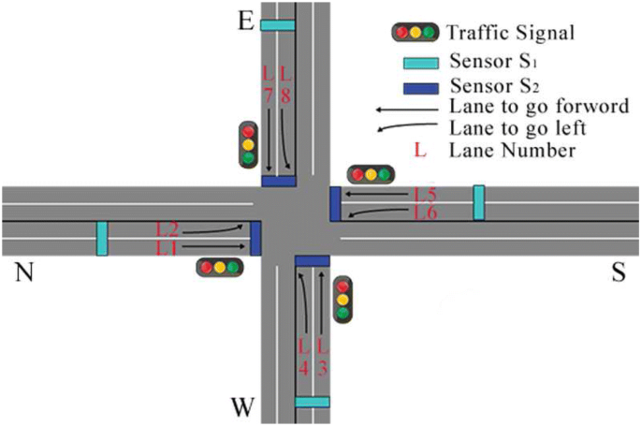

**Figure 1.1 Automatic Traffic Signal**

**1.1 OVERVIEW**

Automatic traffic signal lights based on vehicle density utilize a combination of hardware and software components to monitor and manage traffic at intersections. These systems typically consist of sensors, microcontrollers and programming logic designed to analyze real-time data and adjust signal timings accordingly.

# 1.2 DOMAIN INTRODUCTION

# Automatic traffic signal systems utilize a variety of instruments and components to efficiently regulate traffic flow. Some of the key instruments used in these systems include:

# Traffic Signal Heads

# These are the visible components of traffic signals that display red, yellow and green lights to indicate stop, caution and go respectively. Automatic traffic signal heads are equipped with LED lights for energy efficiency and longevity.

# Detectors

# Detectors are sensors installed in the pavement or overhead that detect the presence and movement of vehicles, bicycles or pedestrians at intersections. They provide input to the traffic signal controller, allowing it to adjust signal timings based on real-time traffic conditions.

# Controller Cabinet

# The controller cabinet houses the electronic control unit that manages the operation of traffic signals. It receives input from detectors and other sensors, processes the data and determines the appropriate signal timings for each phase of the traffic signal cycle.

# Loop Detectors

# Loop detectors are commonly used in pavement to detect the presence of vehicles. They consist of wire loops embedded in the road surface, which generate a magnetic field. When a vehicle passes over the loop, it disrupts the magnetic field, triggering a signal to the controller.

# Radar and Lidar Sensors

# Radar and Lidar sensors use radio waves or laser beams respectively to detect the presence and speed of vehicles approaching an intersection. These sensors are particularly useful in adverse weather conditions or when visual detection is challenging.

# Vehicle Presence Sensors

# These sensors detect the presence of vehicles at intersection approach using various technologies such as microwave, infrared or ultrasonic sensors.

# Communication Equipment

# Automatic traffic signal systems may include communication equipment such as ratio transmitters or receivers to facilitate communication between traffic signals, controllers and central traffic management systems.

# Emergency Vehicle Preemption Devices

# These devices allow emergency vehicles to request priority passage through intersections by sending a signal to the traffic signal controller. The controller then adjusts signal timings to clear a path for the emergency vehicle.

# Pedestrian Push Buttons

# Pedestrian push buttons allow pedestrians to request a signal change to cross the street safely. Automatic traffic signal systems may include audible or tactile feedback to assist pedestrians with disabilities.

# Sensors

# Various types of sensors can be employed to detect vehicles at intersections. Inductive loop sensors, for example, are buried beneath the road surface and detect changes in magnetic fields caused by passing vehicles. Alternatively, infrared sensors can detect the heat emitted by vehicles, while cameras can capture images for computer vision analysis.

# 

# Figure 1.2 Sensors

# These instruments work in concert to enable automatic traffic signal systems to intelligently regulate traffic flow, minimize congestion and improve overall safety on the road

# 

# TARGET COMMUNITY

* Automatic traffic signals are generally designed for public roads and intersections to regulate traffic flow.
* These signals cater to a wide range of communities, including urban areas, suburban neighborhoods, highways and rural intersections where vehicular and pedestrian traffic management is necessary.
* The implementation of automatic traffic signals depends on the specific needs and traffic patterns of a particular area or community.

# PROBLEM STATEMENT

In urban areas, traffic congestion is a significant issue that leads to wasted time, increased fuel consumption, and environmental pollution. Traditional traffic signal systems operate on fixed timing patterns, which may not efficiently accommodate varying traffic demands throughout the day. Population density, which directly correlates with traffic volume, fluctuates over time due to factors such as rush hours, special events, and local activities. However, existing traffic signal systems do not adapt to these changes in real-time, resulting in suboptimal traffic flow and increased congestion.

The problems include:

* Difficult to reduce traffic in 4-point road crossings.
* Inefficiency in signal switching.
* The lanes with more traffic tolerate more waiting time.
* The lanes with less traffic often gets the green signal.
* Hence, petrol is heavily consumed within waiting cars.
* Conflict arises for pedestrians while crossing lanes.

# OBJECTIVE

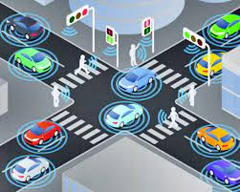

**Figure 1.3 Outline of Traffic Signal**

# Traffic control has as its principal objective to manage the movement of people and goods as efficiently and safely as possible.

* The dual objectives, however, frequently conflict or, at least, compete.
* Reduce waiting time for lanes with more traffic.
* Maintain proper signal switching with balanced timing.
* Prevent traffic collisions.
* Allocate timings exclusively for pedestrians to cross lanes.

**CHAPTER 2**

# LITERATURE SURVEY

**VENUE:** Trichy

**PROBLEM FACED**

Traffic jam is a way of life for Trichy road users Frequent traffic snarls on Cauvery bridge Chathiram Bus stand and the bus travel through karur bypass road. Particularly drive along Anna Statue road to karur bypass road invariably get caught in traffic jam even during non-peak hours morotists have been facing a testing time in recent days.

**SOLUTION FOR THE PROBLEM**

The Goal of minimizing traffic flow the problem can be solved by the real time strategy like signal timing constraints in the rapid development in traffic signals.

**VENUE:** Karur

**PROBLEM FACED**

Most of the motorists invariably have to spend at least 10 to 15 minutes to get through the arterial stretch.

Vehicles could be seen lining up for a long distance from the traffic signal become narrow making it difficult for the vehicles to move freely.

**SOLUTION FOR THE PROBLEM**

The primary reliable and most common traffic timer sensors are induction loop when the surface of the road and the population can be changes the inductance loop then conveying them to the sensors circuitry in order to produce traffic signal.

**VENUE:** Erode

**PROBLEM FACED**

They can often end up causing unnecessary delays leaving vehicles to sit at intersections for long period of time when no traffic is around.

**SOLUTION FOR THE PROBLEM**

A Primary objective of signal time setting of signal provide the orderly movement of conflicting flows of vehicle so the people move through an intersection safely and efficiently.

### CHAPTER 3

**PROJECT SYSTEM**

**3.1 EXISTING SYSTEM**

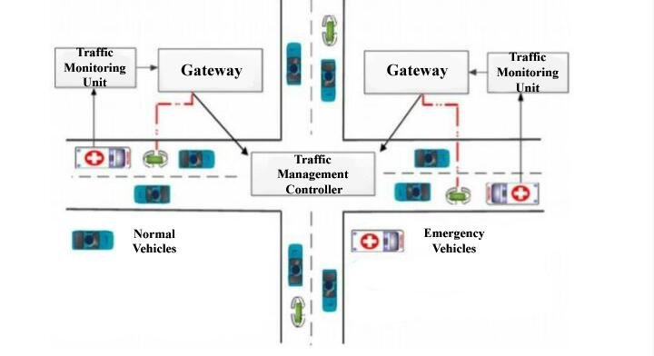

**Figure 3.1 Existing Proposed Architecture**

**3.2 PROPOSED METHODOLOGY**

## The first step is to make sure that the signals are all in ON condition. During this all the traffic signals will blink in yellow light. This indicates that they are all in the working condition.

## The next step is to check for density of traffic in these roads by using UV sensors.

## Establish a robust network for seamless data exchange.

## Include priority settings for emergency vehicle.

## Thoroughly test and optimize algorithms.

## Educate the public about the system’s benefits.

**3.3 PROPOSED ARCHITECTURE**

* An automatic traffic signal based on population would adjust signal timings based on the number of vehicles expected from different directions.
* Population Sensor: Detects the population or vehicle density in each direction.
* Directory database: Analyzes the population data and determines the optimal signal timings.
* Signal Controller: Adjusts the traffic signals based on the instructions from the data processing unit.

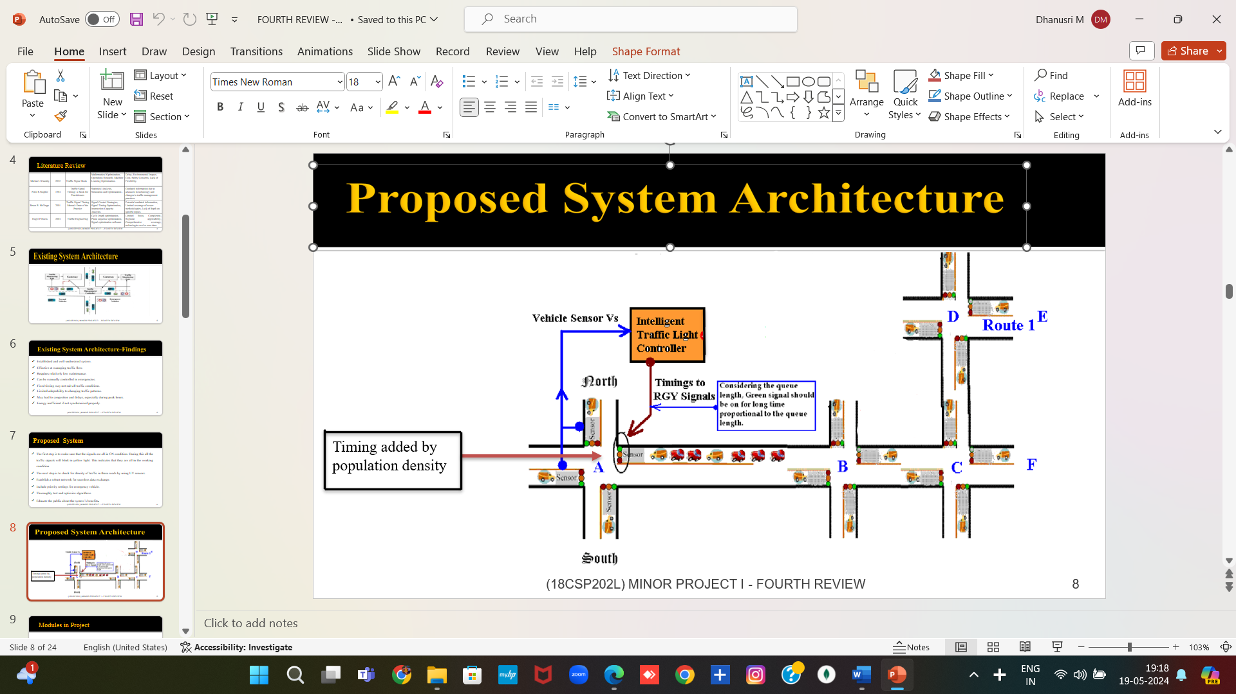

**Figure 3.2 Proposed Architecture**

* Traffic Lights: Actual lights that change based on the signal controller's instructions.
* The population sensor could be a camera system or other sensors that count vehicles or people in each direction.
* The data processing unit would use this information to dynamically adjust signal timings, giving more time to the direction with higher population density to ensure smooth traffic flow.
* The Output of the Population in traffic control signal determined buy the readers in the intersection road of four way (R1P, R2P, R3P, R4P) and two way (R4r, R4r).
* It directs the Traffic signal control to the Directory database and it passes to the Traffic light Signal of Data input and output Device.
* Then the Output is passed to the traffic signal countdown timer.
* An automatic traffic signal system is implemented to efficiently manage traffic flow in densely populated areas.
* This technology utilizes sensors and algorithms to dynamically adjust signal timings based on real-time traffic conditions, alleviating congestion and enhancing overall road safety.
* By adapting to population density and traffic patterns, these intelligent systems optimize signal cycles, reducing wait times and promoting smoother traffic movement.

**CHAPTER 4**

**MODULES**

**4.1 BLOCK DIAGRAM FOR AUTOMATIC TRAFFIC SIGNAL**

## 

Time Calculation Based on Population

Vehicle Based on

Sensor

## Figure 4.1 Automatic Traffic Signal Based on

## Population

## Traffic signal timing is managed by a special computer called a traffic signal controller. This controller is programmed with the time needed for each signal phase (green and walk times) and clearance times (red, yellow, and don't walk times).

## Density based traffic light control is an automated way of controlling signals in accordance to the density of traffic on the roads. ultrasonic sensors are placed in the entire intersecting road at the fixed distances from the signal placed in the junction.

## The sensors provide input to the controller which then performs some logical operations to power the traffic lights as output used for controlling traffic at road intersections.

## This design work, a density based traffic light control system was developed for traffic control at '+' road intersection to reduce unnecessary time wastage and minimize road traffic casualties which the existing conventional traffic light control system has failed to achieve.

replicating stochastic characteristics and preemption control impacts on traffic flow;

• replicating and assessing the performance of different traffic signal transition strategies;

• assessing the impacts of varying levels of traffic volume (e.g., 0.40 to 0.60 v/c) on the

performance of different traffic signal transition strategies;

• allowing for this simulation tool to be used entirely on a personal computer; and

• providing an enhanced methodology and simulation tool to evaluate traffic control

functions and features that are not currently supported by traffic simulation models

replicating stochastic characteristics and preemption control impacts on traffic flow;

• replicating and assessing the performance of different traffic signal transition strategies;

• assessing the impacts of varying levels of traffic volume (e.g., 0.40 to 0.60 v/c) on the

performance of different traffic signal transition strategies;

• allowing for this simulation tool to be used entirely on a personal computer; and

• providing an enhanced methodology and simulation tool to evaluate traffic control

functions and features that are not currently supported by traffic simulation models

replicating stochastic characteristics and preemption control impacts on traffic flow;

• replicating and assessing the performance of different traffic signal transition strategies;

• assessing the impacts of varying levels of traffic volume (e.g., 0.40 to 0.60 v/c) on the

performance of different traffic signal transition strategies;

• allowing for this simulation tool to be used entirely on a personal computer; and

• providing an enhanced methodology and simulation tool to evaluate traffic control

functions and features that are not currently supported by traffic simulation models

replicating stochastic characteristics and preemption control impacts on traffic flow;

• replicating and assessing the performance of different traffic signal transition strategies;

• assessing the impacts of varying levels of traffic volume (e.g., 0.40 to 0.60 v/c) on the

performance of different traffic signal transition strategies;

• allowing for this simulation tool to be used entirely on a personal computer; and

• providing an enhanced methodology and simulation tool to evaluate traffic control

functions and features that are not currently supported by traffic simulation models

**4.2 MODULE DESCRIPTION**

Programming for displaying results from a microprocessor and sensors in an IoT

system typically involves a few key components:

* **Embedded Programming**

The microprocessor or microcontroller (e.g., Arduino, ESP8266, ESP32) is programmed using languages like C or C++ to read sensor data and send it to the IoT platform.

* **IoT Platform**

Data from the microprocessor is transmitted to an IoT platform (e.g., AWS IoT, Google Cloud IoT, Thing Speak). These platforms often use MQTT or HTTP protocols for communication. The programming here might involve Python, Node.js, or other scripting languages to handle data ingestion and processing.

* **Frontend Development**

To display the results, web technologies such as HTML, CSS, and JavaScript are used. Libraries and frameworks like React, Angular, or Vue.js can be utilized to create interactive dashboards.

* **Backend Development**

Backend servers handle data storage and provide APIs for the frontend. Common languages for backend development include Python (with frameworks like Flask or Django), Node.js, or Java.

**For a typical workflow:**

* **Microcontroller Programming**

Use Arduino IDE, Platform IO, or similar tools.

* **Data Transmission**

Employ MQTT or HTTP protocols.

* **IoT Platform**

Set up data storage and processing.

* **Visualization**

Develop web-based dashboards using JavaScript frameworks or use ready-made tools provided by the IoT platform.

* **Sensor**

Active infrared sensors provide vehicle presence at traffic signals, volume, speed measurement, length assessment, queue measurement, and classification. Multiple units can be installed at the same intersection without interference from transmitted or received signals.

* **Timing And Sensing Vehicle**

A timer is a specialized type of clock used for measuring specific time intervals. Timers can be categorized into two main types. A timer which counts upwards from zero for measuring elapsed time is often called a stopwatch, while a device which counts down from a specified time interval is more usually called a timer. A simple example of this type is an hourglass.

* **Communication**

Traffic sensors and detectors located at intersections provide real-time data on traffic flow, vehicle presence, and queue lengths. This data can be used by the signal controllers to adjust timing dynamically.

* **Execution**

Geomagnetic vehicle detection use changes in magnetic fields on traffic light systems to detect cars, radar technique detects moving vehicles (though it is frequently used for pedestrian detection because the radars are rarely immobile), and laser technique measures the distance of the vehicle from the intersection (or road surface).

**4.3 HARDWARE AND SOFTWARE REQUIREMENTS**

## Software Requirements:

## Language: Embedded C.

## Hardware Requirements:

* 8051 Microcontroller.
* IR Sensor.

# CHAPTER 5

## RESULTS AND DISCUSSION

**Module 1:**

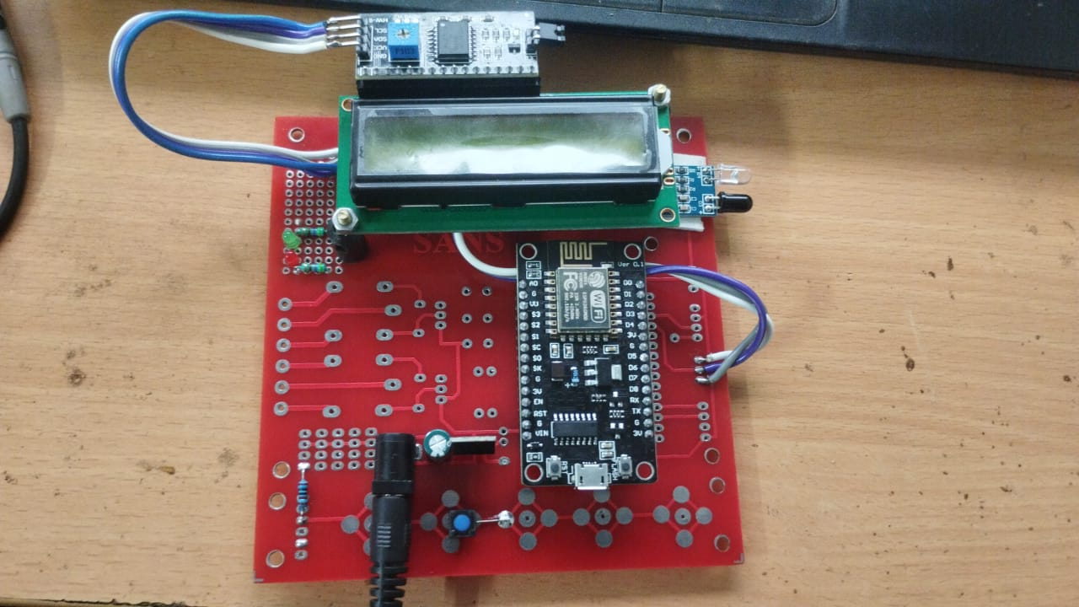

## 

## Figure 5.1 IR Sensor

## IR Sensors are used as sensors to detect the density of traffic and 8051 used as microcontroller. At traffic junction IR sensors are fitted at every side of the junction and sense the number of passing vehicle to each side of junction and interfaced to the 8051 microcontroller.

**Module 2:**

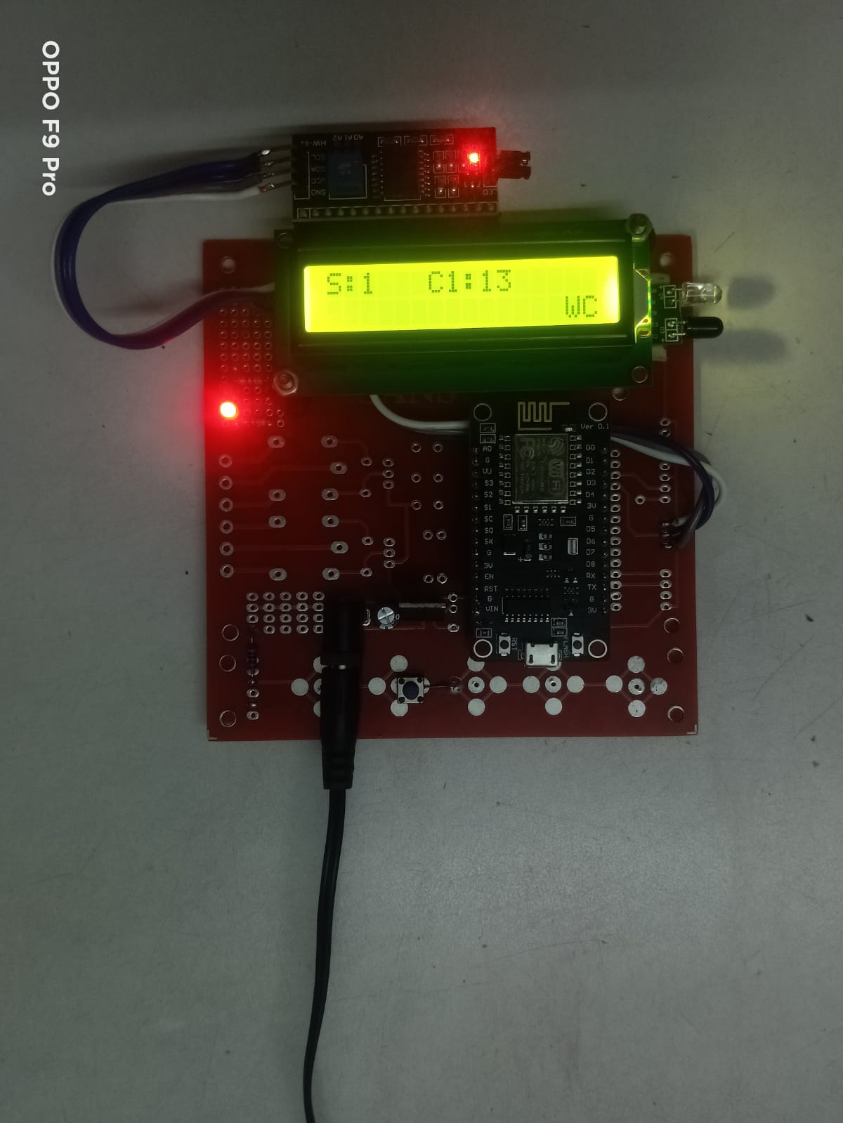 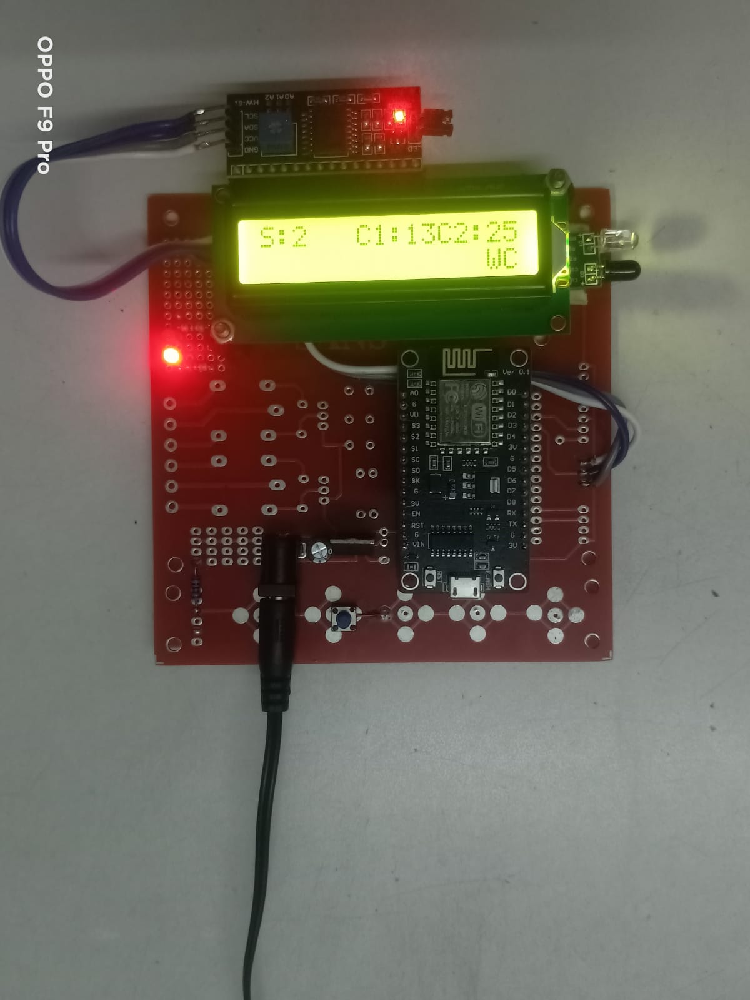

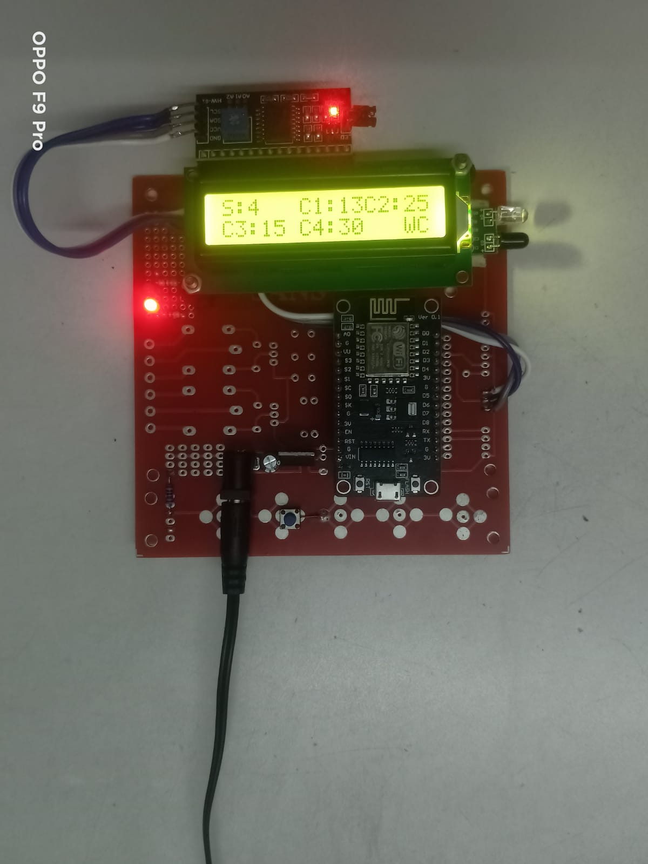 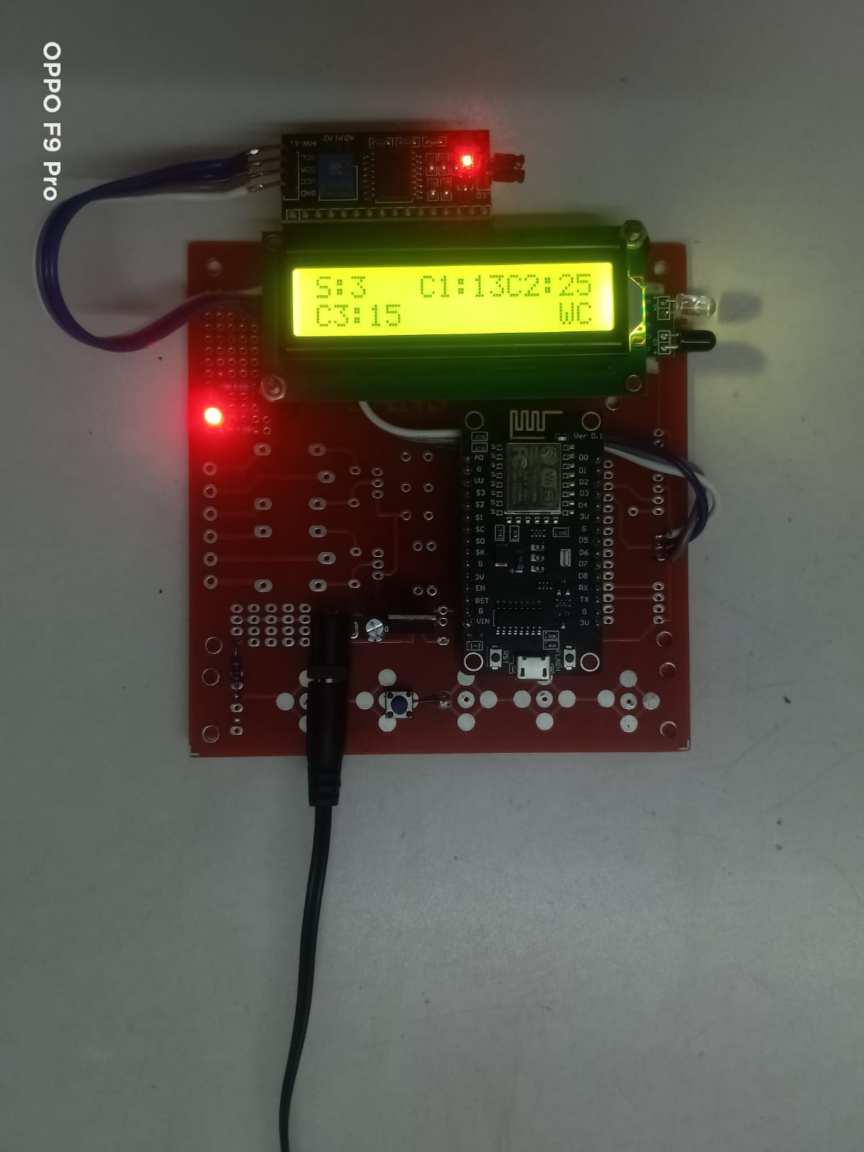

**Figure 5.2 Timing and Sensing Vehicle**

In IR Sensor and 8051 microcontroller, It sense the Vehicle density one by one, by IR Sensor with the help of 8051 microcontroller to display the no. of Vehicles. It dynamically changed the next port to sense the vehicle and it finally display the no. of Vehicle and Add Timing according to density.

**Module 3:**



**Figure 5.3 Communication**

IR Sensor communicate the density to add timing to the signal to which signal should execute First and the execute one by one

**Module 4:**

.

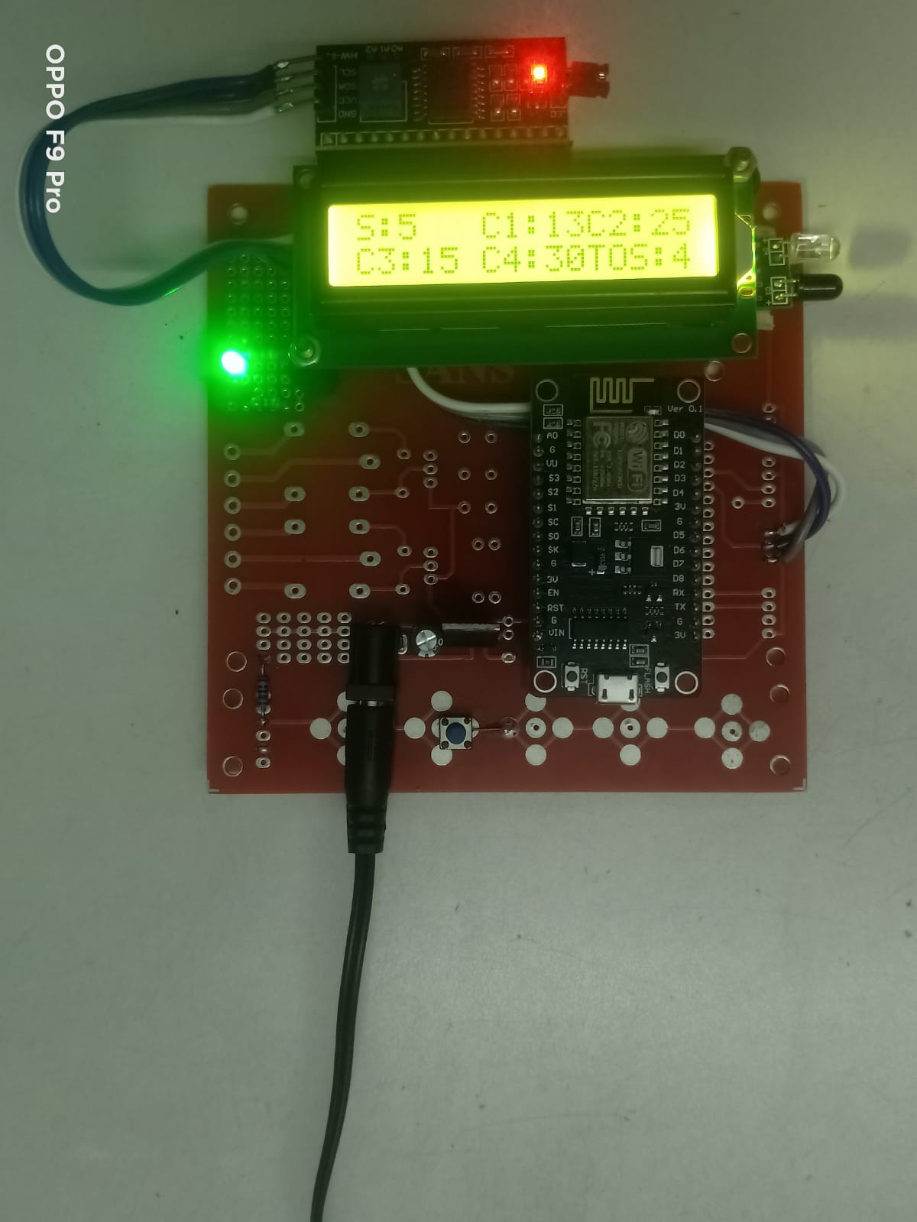

**Figure 5.4 Execution**

It Execute the Most Density Area to get the Green Signal and Execute One by One Signal According to the Density.

**Web Site Execution:**

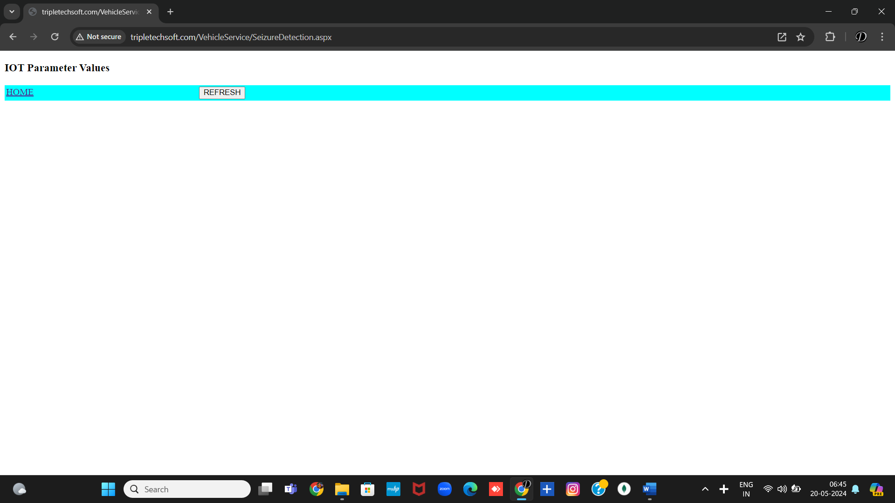

**Figure 5.5 Web Site Home page**

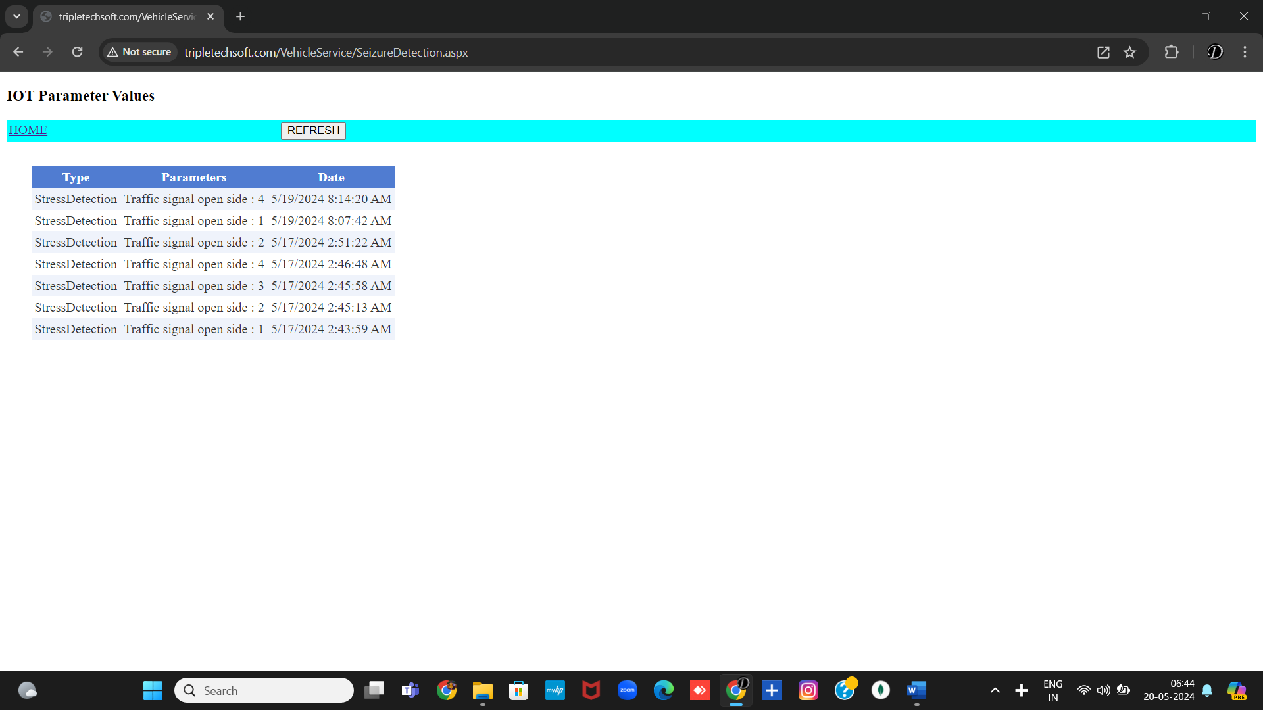

**Figure 5.6 Web Site Home Page After Execution**

**CHAPTER 6**

**6.1 CONCLUSION**

By using this system configuration can reduce the possibilities of traffic jams. The number of passing vehicles on the road decides the density range of traffics and on the basis of vehicle count microcontroller decides the traffic light delays. Traffic load and emergency vehicles are continuously measured by sensors connected to a microcontroller based system which also performs all intersection control functions.

**6.2 FUTURE SCOPE**

The traffic signs focus on reduction of the traffic load on existing road network through various travel demand management measures. Traffic signs should remove the encroachments, congestion and improve the traffic signal, road condition and geometrics features at intersections. The system can be expanded with smart traffic light control and congestion avoidance system during emergencies such as fire engines and ambulances and have priority over other traffic. This system gives highest priority to emergency vehicles to pass them.

**REFERENCES**

1. www.researchgate.com
2. [www.ieee.org](http://www.ieee.org)
3. <https://www.hindawi.com/journals/wcmc/2020/8841893/>
4. [https://www.researchgate.net/publication/338919777_Automatic_Traffic_Lig ht_Control_System](https://www.researchgate.net/publication/338919777_Automatic_Traffic_Lig%20%20%20ht_Control_System)
5. <https://www.efkonindia.com/products-svd.php?PRODUCTS&SVD>

**APPENDIX**

**Problem Identified from Survey**



**Figure A.1 Survey form 1 for problem Identified**



**Figure A.2 Survey form 2 for problem Identified**



**Figure A.3 Survey form 3 for problem Identified**

**Proposed Methodology for Survey**

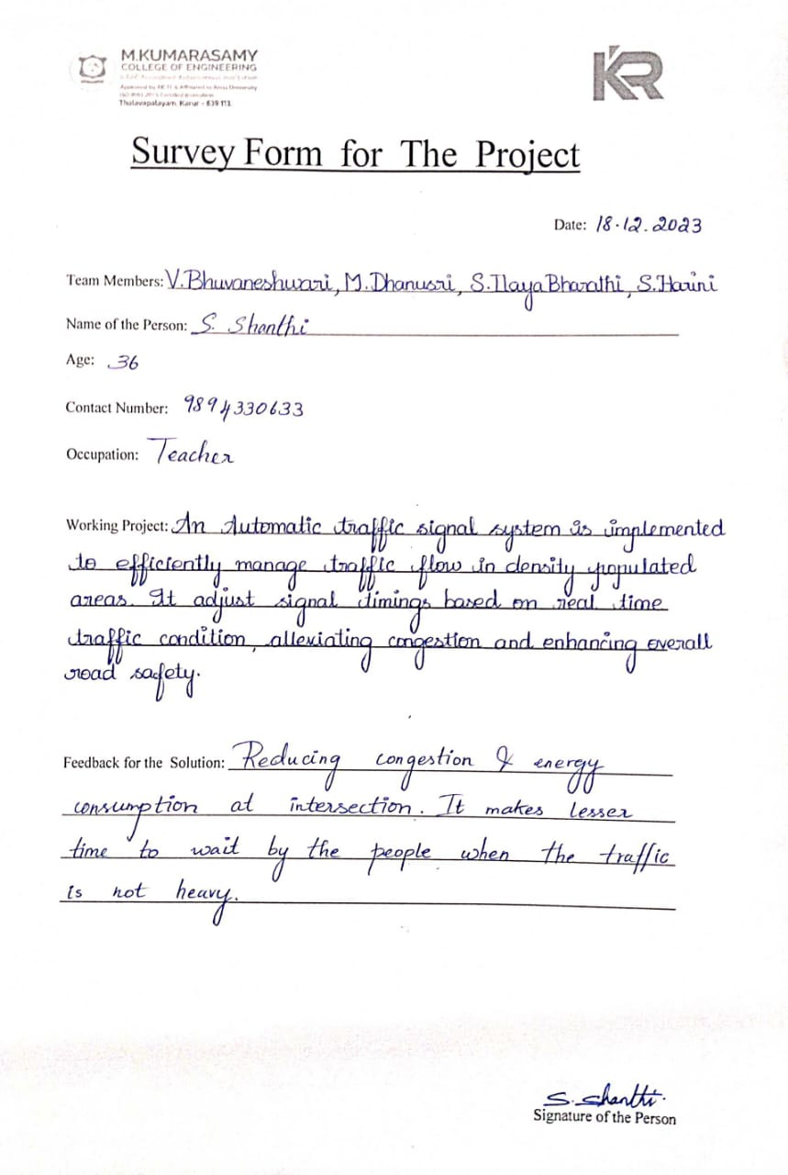

**Figure A.4 Survey form 1 for proposed methodology**



**Figure A.5 Survey form 2 for proposed methodology**



**Figure A.6 Survey form 3 for proposed methodology**

**Survey on Full Implementation:**



**Figure A.7 Survey form 1 on Full Implementation**



**Figure A.8 Survey form 2 on Full Implementation**

**Embedded C:**

#include<reg51.h>

//signal 1

sbit tl1r = P2^0; // red

sbit tl1o = P2^1; // orange

sbit tl1g = P2^2; // green

//signal 2

sbit tl2r = P2^3; // red

sbit tl2o = P2^4; // orange

sbit tl2g = P2^5; // green

//signal 3

sbit tl3r = P3^0; // red

sbit tl3o = P3^1; // orange

sbit tl3g = P3^2; // green

void delay(int t);

void trafficlight(void);

void main() // main program

{

P2=0x00; // turned off the lights

P3=0x00; // turned off the lights

while(1)

{

trafficlight();

}

}

void delay(unsigned long int t) // delay routine

{

while(t>0)

{

unsigned long int i;

for(i=1;i<10*1275;i++);

t--;

}

}

void trafficlight(void) // traffic light system program

{

P2= 0x11; // traffic signal control data

P3= 0x04;

/*

tl1r=1; // signal 1

tl1o=0;

tl1g=0;

tl2r=0; // signal 2

tl2o=1;

tl2g=0;

tl3r=0; // signal 3

tl3o=0;

tl3g=1;

*/

delay(100); // delay

P2= 0x0c; // traffic signal control data

P3= 0x02;

/*

tl1r=0; // signal 1

tl1o=0;

tl1g=1;

tl2r=1; // signal 2

tl2o=0;

tl2g=0;

tl3r=0; // signal 3

tl3o=1;

tl3g=0;

*/

delay(100); // delay

P2= 0x22; // traffic signal control data

P3= 0x01;

/*

tl1r=0; // signal 1

tl1o=1;

tl1g=0;

tl2r=0; // signal 2

tl2o=0;

tl2g=1;

tl3r=1; // signal 3

tl3o=0;

tl3g=0;

*/

delay(100); // delay

}

**Web Page QR Code:**



**Figure A.9 QR Code for Traffic Signal Execution**

**Web Site Link:**

tripletechsoft.com/VehicleService/SeizureDetection